**Putting it all together**

Over all , you start with a given text, you perform preprocessing, then you do feature extraction to convert text into numerical representation as follows:

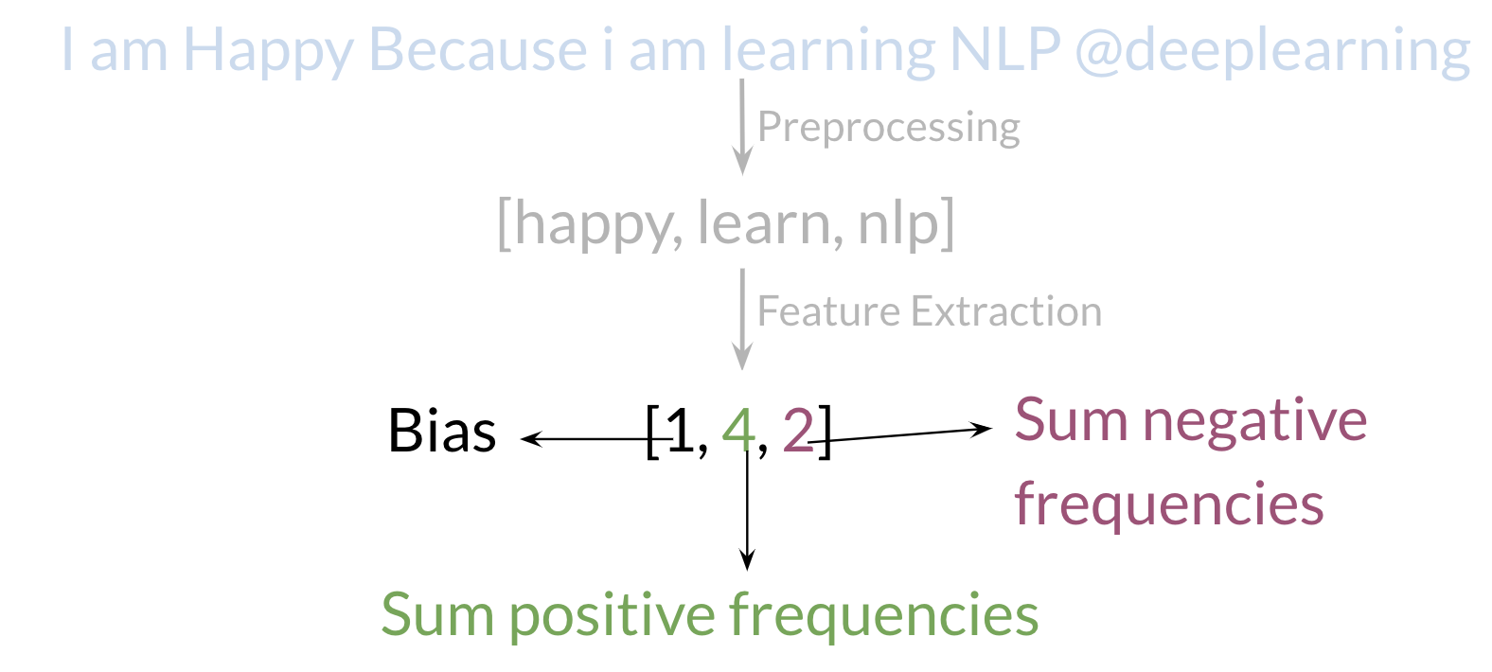

Your X*X* becomes of dimension (m,3)(*m*,3) as follows.

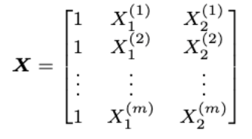

When implementing it with code, it becomes as follows:

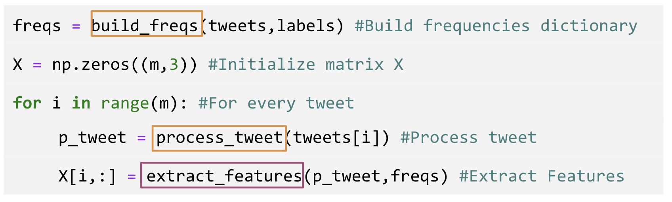

You can see in the last step you are storing the extracted features as rows in your X*X* matrix and you have m*m* of these examples.